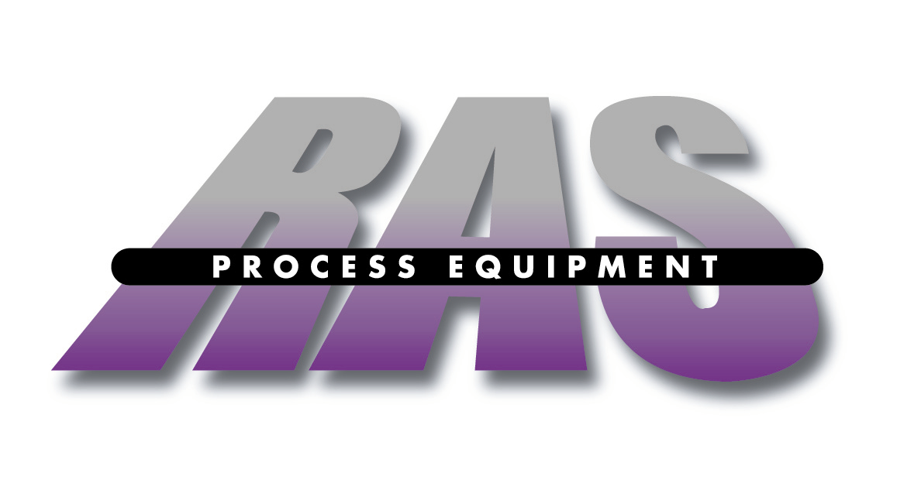

Directions and Local Accommodations to:

RAS Process Equipment
324 Meadowbrook Road
Robbinsville, NJ 08691

Phone: 609-371-1000

From Philadelphia International Airport: Take Interstate 95 North to Walt Whitman Bridge, Route 76 South (South Jersey) to Interstate 295 North (follow below directions from South Jersey)

From South Jersey: Take Route 295 North to Route 195 East to the Route 130 North exit. Take 130 North approximately 3 miles to Meadowbrook Road. National Pools & Spas is on the left. (There is a traffic light and left turn lane). Turn Left onto Meadowbrook Road cross over railroad tracks--RAS Process Equipment is on your Right.

From New York/North Jersey/Newark International Airport: Take New Jersey Turnpike South to Exit 7A (195 Exit). Take 195 West for one exit to Route 130 North exit. Take 130 North approximately 3 miles to Meadowbrook Road. National Pools & Spas is on the left. (There is a traffic light and left turn lane). Make a left onto Meadowbrook Road cross over railroad tracks--RAS Process Equipment is on your Right.

Local Accommodations

Ramada Inn of East Windsor Days Inn
399 Monmouth Street 460 State Highway 33 East
East Windsor, NJ 08520 East Windsor, NJ 08520
(609) 448-7000 (609) 448-3200

